6

SUPPLY, DEMAND, AND GOVERNMENT POLICIES

WHAT’S NEW IN THE SEVENTH EDITION:

There is a new In the News feature on “President Chávez versus the Market.”

LEARNING OBJECTIVES:

By the end of this chapter, students should understand:

➢ the effects of government policies that place a ceiling on prices.

➢ the effects of government policies that put a floor under prices.

➢ how a tax on a good affects the price of the good and the quantity sold.

➢ that taxes levied on sellers and taxes levied on buyers are equivalent.

➢ how the burden of a tax is split between buyers and sellers.

CONTEXT AND PURPOSE:

Chapter 6 is the third chapter in a three-chapter sequence that deals with supply and demand and how markets work. Chapter 4 developed the model of supply and demand. Chapter 5 added precision to the model of supply and demand by developing the concept of elasticity—the sensitivity of the quantity supplied and quantity demanded to changes in economic conditions. Chapter 6 addresses the impact of government policies on competitive markets using the tools of supply and demand that you learned in Chapters 4 and 5.
The purpose of Chapter 6 is to consider two types of government policies—price controls and taxes. Price controls set the maximum or minimum price at which a good can be sold while a tax creates a wedge between what the buyer pays and what the seller receives. These policies can be analyzed within the model of supply and demand. We will find that government policies sometimes produce unintended consequences.

KEY POINTS:

• A price ceiling is a legal maximum on the price of a good or service. An example is rent control. If the price ceiling is below the equilibrium price, then the price ceiling is binding, and the quantity demanded exceeds the quantity supplied. Because of the resulting shortage, sellers must in some way ration the good or service among buyers.

• A price floor is a legal minimum on the price of a good or service. An example is the minimum wage. If the price floor is above the equilibrium price, then the price floor is binding, and the quantity supplied exceeds the quantity demanded. Because of the resulting surplus, buyers’ demands for the good or service must in some way be rationed among sellers.

• When the government levies a tax on a good, the equilibrium quantity of the good falls. That is, a tax on a market shrinks the size of the market.

• A tax on a good places a wedge between the price paid by buyers and the price received by sellers. When the market moves to the new equilibrium, buyers pay more for the good and sellers receive less for it. In this sense, buyers and sellers share the tax burden. The incidence of a tax (that is, the division of the tax burden) does not depend on whether the tax is levied on buyers or sellers.

• The incidence of a tax depends on the price elasticities of supply and demand. Most of the burden falls on the side of the market that is less elastic because that side of the market cannot respond as easily to the tax by changing the quantity bought or sold.

CHAPTER OUTLINE:
I. Controls on Prices
A. Definition of price ceiling: a legal maximum on the price at which a good can be sold.

B. Definition of price floor: a legal minimum on the price at which a good can be sold.

C. How Price Ceilings Affect Market Outcomes

1. There are two possible outcomes if a price ceiling is put into place in a market.
a. If the price ceiling is higher than or equal to the equilibrium price, it is not binding and has no effect on the price or quantity sold.
b. If the price ceiling is lower than the equilibrium price, the ceiling is a binding constraint and a shortage is created.
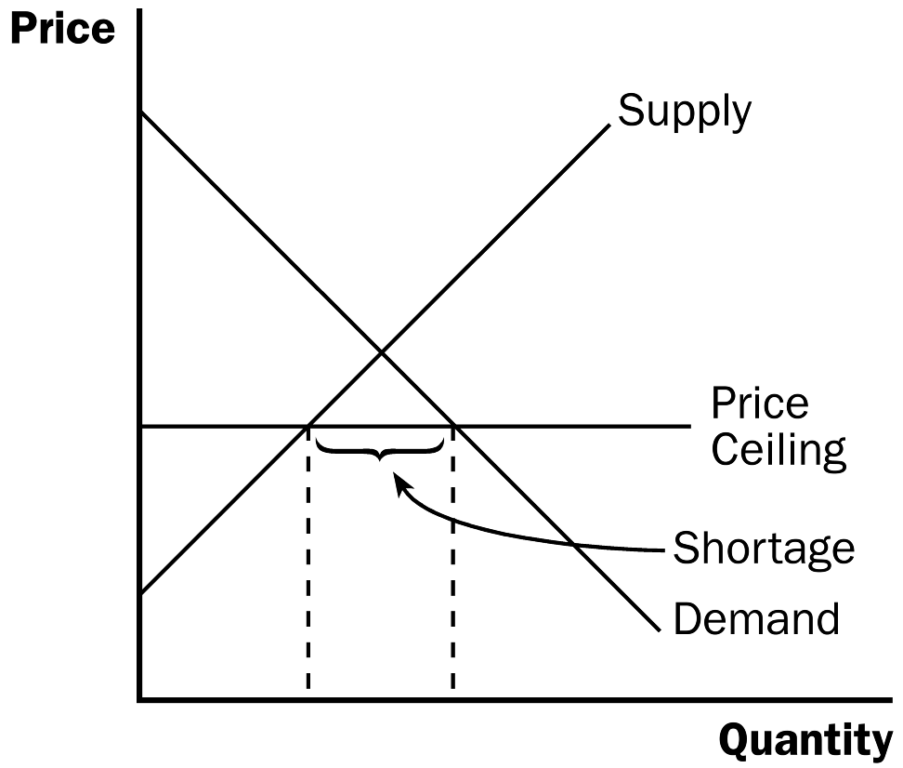
Figure 1

2. If a shortage for a product occurs (and price cannot adjust to eliminate it), a method for rationing the good must develop.

3. Not all buyers benefit from a price ceiling because some will be unable to purchase the product.

4. Case Study: Lines at the Gas Pump

Figure 2

a. In 1973, OPEC raised the price of crude oil, which led to a reduction in the supply of gasoline.

b. The federal government put a price ceiling into place and this created large shortages.

c. Motorists were forced to spend large amounts of time in line at the gas pump (which is how the gas was rationed).

d. Eventually, the government realized its mistake and repealed the price ceiling.
ALTERNATIVE CLASSROOM EXAMPLE:
Ask students about the rental market in their town. Draw a supply-and-demand graph for two-bedroom apartments asking students what they believe the equilibrium rental rate is. Then suggest that the city council is accusing landlords of taking advantage of students and thus places a price ceiling below the equilibrium price. Make sure that students can see that a shortage of apartments would result. Ask students to identify the winners and losers of this government policy.

5. Case Study: Rent Control in the Short Run and the Long Run

Figure 3

a. The goal of rent control is to make housing more affordable for the poor.

b. Because the supply of apartments is fixed (perfectly inelastic) in the short run and upward sloping (elastic) in the long run, the shortage is much larger in the long run than in the short run.

c. Rent-controlled apartments are rationed in a number of ways including long waiting lists, discrimination against minorities and families with children, and even under-the-table payments to landlords.

d. The quality of apartments also suffers due to rent control.

D. How Price Floors Affect Market Outcomes

1. There are two possible outcomes if a price floor is put into place in a market.

Figure 4
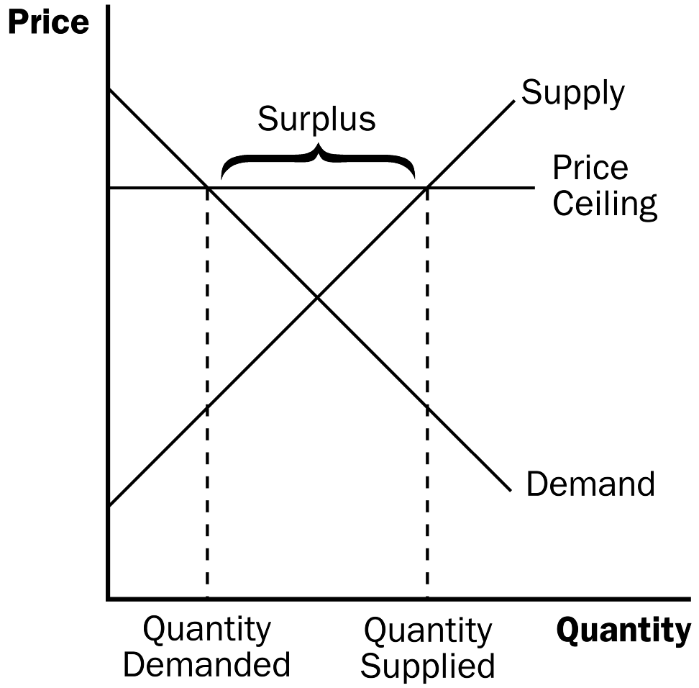
a. If the price floor is lower than or equal to the equilibrium price, it is not binding and has no effect on the price or quantity sold.

b. If the price floor is higher than the equilibrium price, the floor is a binding constraint and a surplus is created.

ALTERNATIVE CLASSROOM EXAMPLE:
Go through an example with an agricultural price support. Show students that, even though a price support is not a legal minimum price, its result is exactly the same as a price floor. Make sure that students can see that a surplus will result. Ask students to identify the winners and losers of this government policy. Make sure that you also point out the costs of the program (purchasing the surplus and storing it).

2. Case Study: The Minimum Wage

Figure 5
a. The market for labor looks like any other market: downward-sloping demand, upward-sloping supply, an equilibrium price (called a wage), and an equilibrium quantity of labor hired.

b. If the minimum wage is above the equilibrium wage in the labor market, a surplus of labor will develop (unemployment).

c. The minimum wage will be a binding constraint only in markets where equilibrium wages are low.

d. Thus, the minimum wage will have its greatest impact on the market for teenagers and other unskilled workers.

E. In the News: President Chávez versus the Market

1. Price ceilings imposed by the government with the intention of aiding the poor can harm rich and poor people alike due to shortage.

2. This article from The New York Times discussing grocery shortages in Venezuela.

F. Evaluating Price Controls

1. Because most economists feel that markets are usually a good way to organize economic activity, most oppose the use of price ceilings and floors.

a. Prices balance supply and demand and thus coordinate economic activity.

b. If prices are set by laws, they obscure the signals that efficiently allocate scarce resources.


This is a good chance to reinforce the principle “Markets are usually a good way to organize economic activity.”

2. Price ceilings and price floors often hurt the people they are intended to help.

a. Rent controls create a shortage of quality housing and provide disincentives for building maintenance.

b. Minimum wage laws create higher rates of unemployment for teenage and low skilled workers.

Be prepared to answer the question, “If price controls have such adverse consequences, why are they imposed?” You may want to point out that, sometimes, economic ignorance leads to unintended outcomes. You may also want to point out that economic analysis serves as only a guide to policymakers. They may choose to ignore it when forming policy. In addition, it is often interesting to encourage the students to think about the distributional effects of these government programs.

Activity 1—Ducks in a Row

Type: In-class demonstration
Topics: Price ceilings, subsidies, and unintended consequences
Materials needed: 2 toy ducks, some play money, 3 volunteers
Time: 10 minutes
Class limitations: Works in any size class

Purpose
This demonstration illustrates some common problems of government intervention in markets.

Instructions
One volunteer plays the role of the government in a poor country. Give the play money to the “government,” except for $1. The government uses this money to buy ducks from the farmer and provides the ducks to the shopkeeper. The second volunteer is an urban shopkeeper. The shopkeeper asks the government for more ducks whenever he or she is sold out. Give the shopkeeper one duck. The third volunteer is a consumer. The consumer buys ducks. Give the consumer $1 in play money. The instructor is a duck farmer. The farmer keeps the second duck.

Explain this background: “Ducks are a staple food in this country but they are expensive at $3 each. The government wants to make food cheap for the urban poor to alleviate hunger. They calculate people could afford ducks if they were priced at $1. The government decides to impose a price ceiling of $1; $1 is now the maximum retail price for ducks.”

Start the game. The consumer buys one duck from the shopkeeper. The shopkeeper requests more ducks from the government. The government comes to the farmer.

Points for Discussion
The instructor, as the duck farmer, controls the game. There are three points to make in this demonstration:
1. Shortage. The farmer refuses to sell ducks at $1 each. The shopkeeper has no ducks.
2. Subsidy. The farmer offers to sell the ducks for $3. The ducks can then be sold in the marketplace for $1. The government pays a $2 subsidy to keep food prices low.
3. Black markets. After the farmer sells the duck to the government for $3, the duck goes to the shopkeeper for $1. The farmer buys back the original duck for $1 and resells it to the government for $3. This can continue until the government runs out of money.

Examples of unit taxes include most government excise taxes on products such as gasoline, alcohol, and tobacco.
Use this chance to reinforce the three steps learned in Chapter 4. Students should decide whether this tax law affects the demand curve or the supply curve, decide which way it shifts, and then examine how the shift affects equilibrium price and quantity.

II. Taxes

A. Definition of tax incidence: the manner in which the burden of a tax is shared among participants in a market.

B. How Taxes on Sellers Affect Market Outcomes

1. If the government requires the seller to pay a certain dollar amount for each unit of a good sold, this will cause a decrease in supply.

2. The supply curve will shift left by the exact amount of the tax.

Figure 6
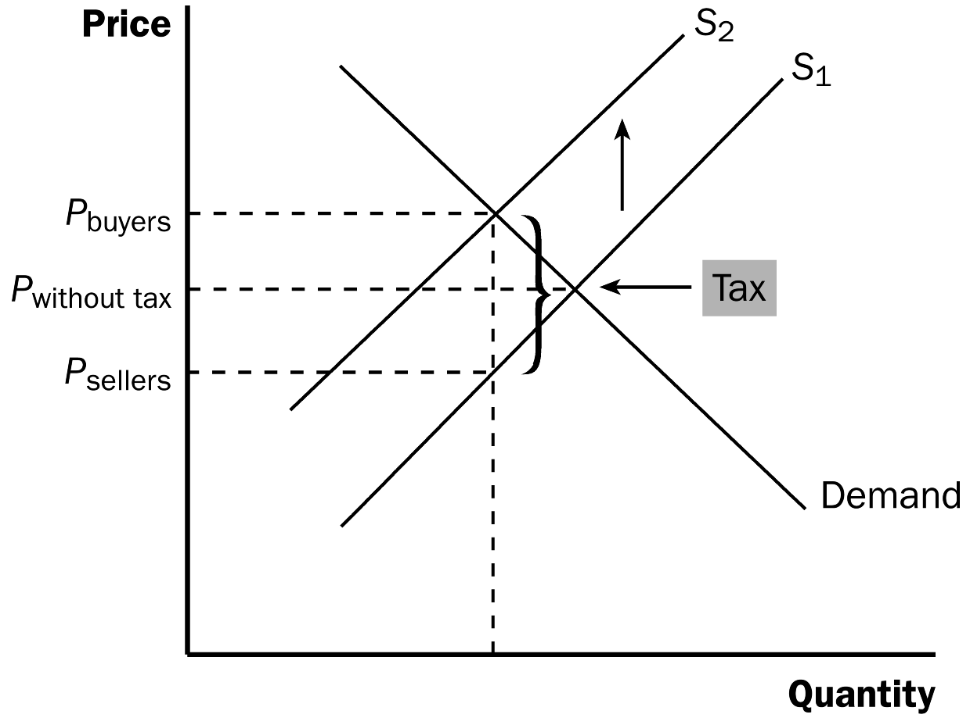


You will want to be very careful when discussing the “upward” shift of the supply curve given that we encourage students to think of supply and demand curves shifting “right” and “left.” Make sure to emphasize the effects of the tax on sellers’ willingness to sell.

3. The quantity of the good sold will decline.

4. Buyers and sellers will share the burden of the tax; buyers pay more for the good (including the tax) and sellers receive less.

5. Two lessons can be learned here.

a. Taxes discourage market activity.

b. Buyers and sellers share the burden of a tax.

C. How Taxes on Buyers Affect Market Outcomes

1. If the government requires the buyer to pay a certain dollar amount for each unit of a good purchased, this will cause a decrease in demand.

2. The demand curve will shift left by the exact amount of the tax.

Again, be very careful when discussing the “downward” shift of the demand curve. Describe the effects of the tax on buyers’ willingness to buy.

Figure 7
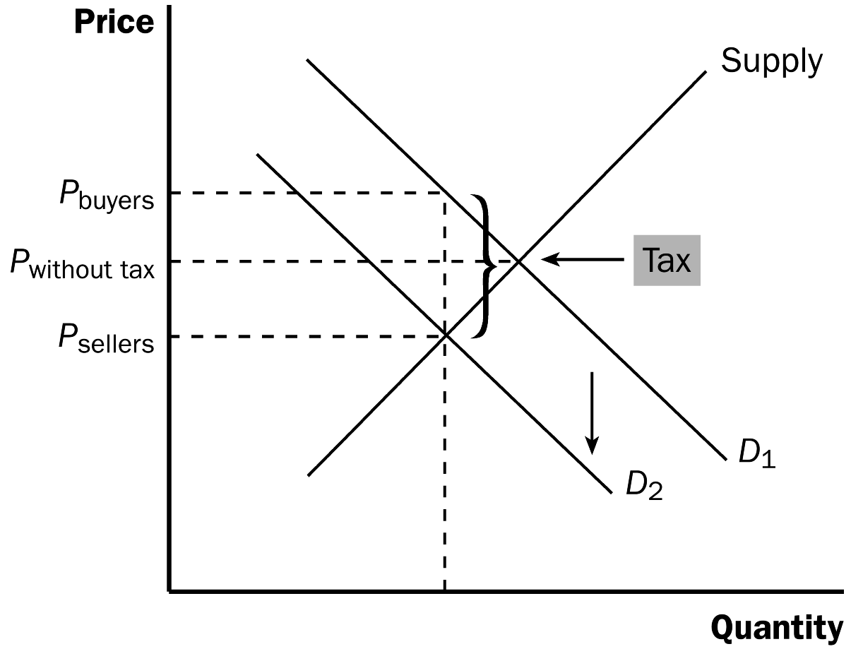

3. The quantity of the good sold will decline.

4. Buyers and sellers will share the burden of the tax; buyers pay more for the good and sellers receive less (because of the tax).

Stress that the outcome of a tax levied on sellers is exactly the same as the outcome of a tax levied on buyers. When drawing this in class, make sure that the price that buyers end up paying and the price that sellers end up receiving is the same in both examples.

D. Case Study: Can Congress Distribute the Burden of a Payroll Tax?

Figure 8

1. FICA (Social Security) taxes were designed so that firms and workers would equally share the burden of the tax.

2. This type of payroll tax will simply put a wedge between the wage the firm pays and the wage the workers will receive.

3. It is true that firms and workers share the burden of this tax, but it is not necessarily 50-50.

Go through this material slowly. Make sure that students can see how to find the burden of the tax paid by consumers and the burden of the tax paid by producers before discussing the effects of elasticity on tax incidence. If you rush through this material, you will lose them.

E. Elasticity and Tax Incidence

1. When supply is elastic and demand is inelastic, the largest share of the tax burden falls on consumers.

2. When supply is inelastic and demand is elastic, the largest share of the tax burden falls on producers.

3. In general, a tax burden falls more heavily on the side of the market that is less elastic.

a. A small elasticity of demand means that buyers do not have good alternatives to consuming this product.

b. A small elasticity of supply means that sellers do not have good alternatives to producing this particular good.

Figure 9

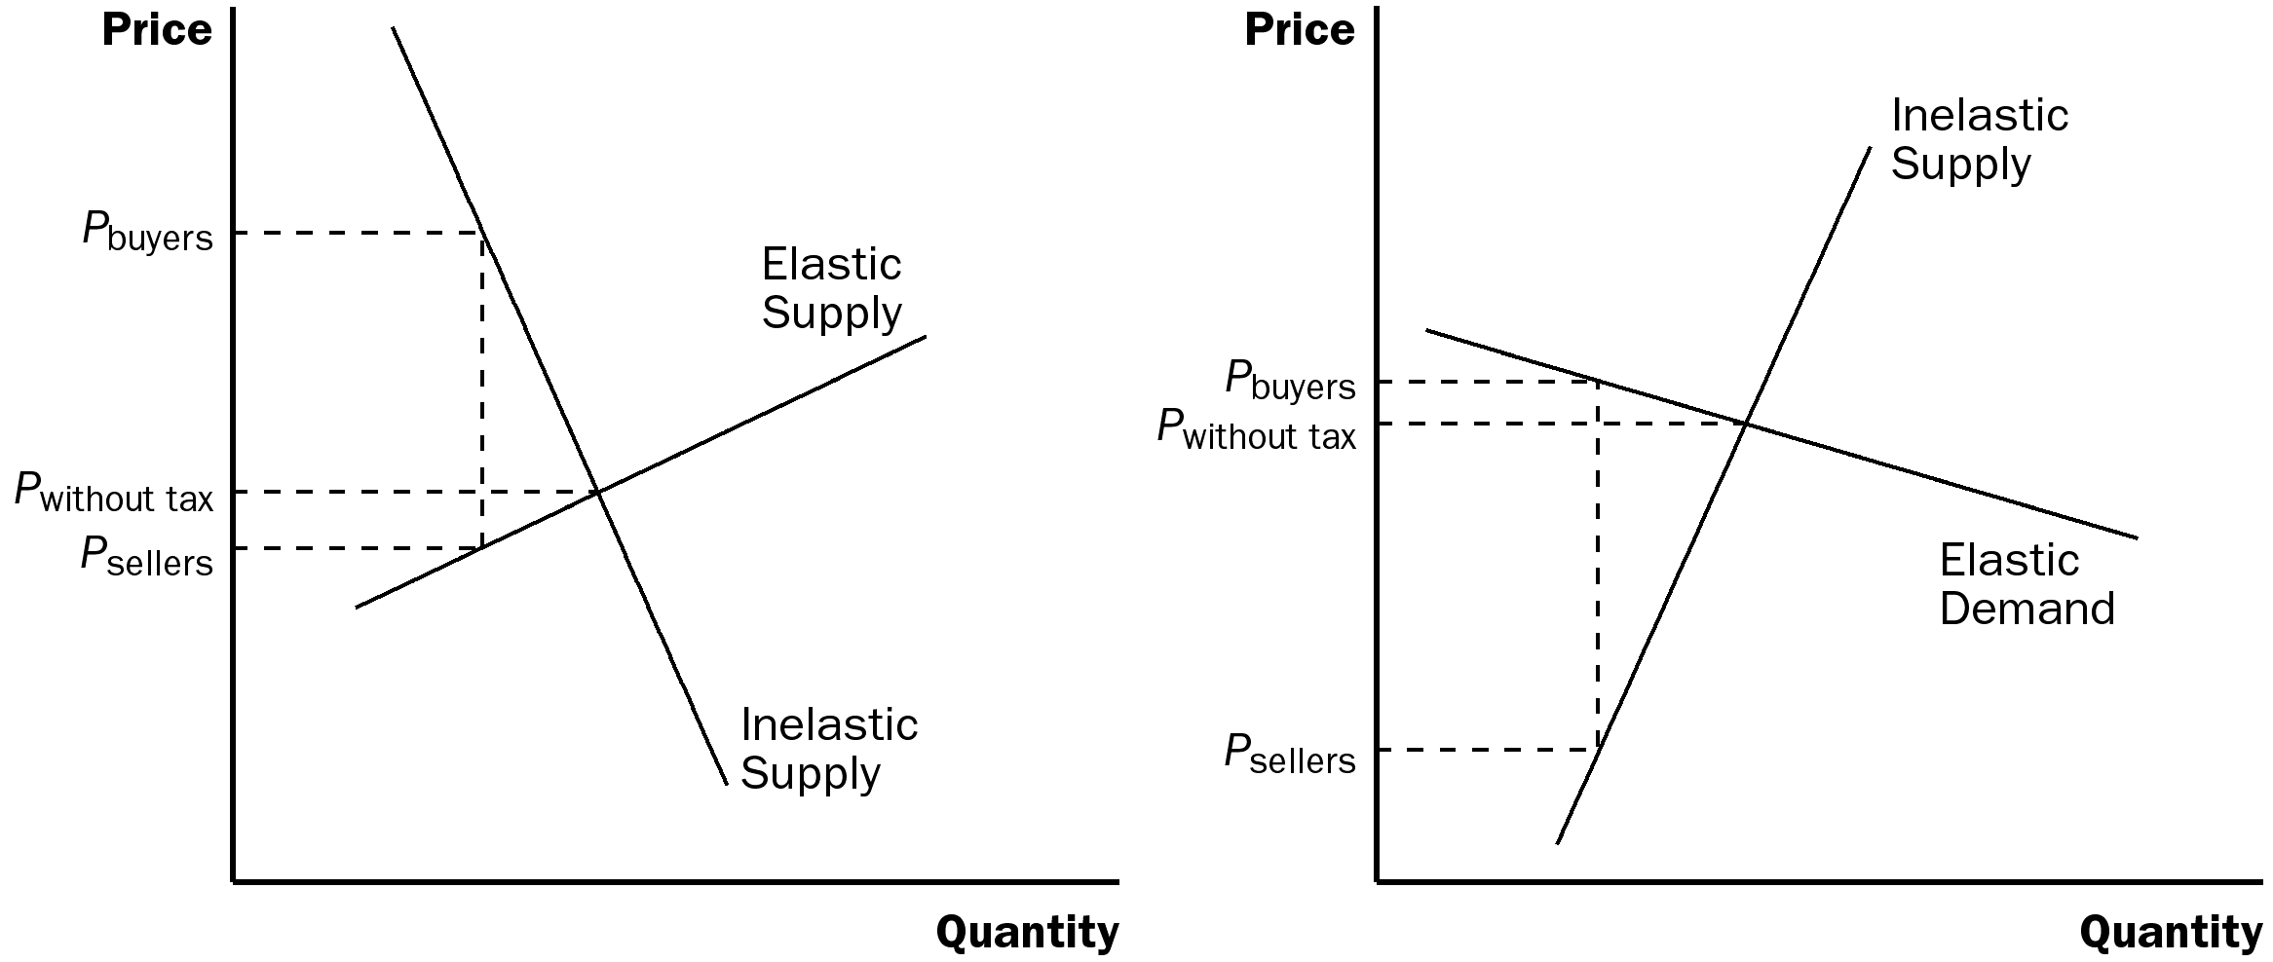

4. Case Study: Who Pays the Luxury Tax?

a. In 1990, Congress adopted a new luxury tax.

b. The goal of the tax was to raise revenue from those who could most easily afford to pay.

c. Because the demand for luxuries is often relatively more elastic than supply, the burden of the tax fell on producers and their workers.

SOLUTIONS TO TEXT PROBLEMS:

Quick Quizzes

1. A price ceiling is a legal maximum on the price at which a good can be sold. Examples of price ceilings include rent controls, price controls on gasoline in the 1970s, and price ceilings on water during a drought. A price floor is a legal minimum on the price at which a good can be sold. Examples of price floors include the minimum wage and farm price supports. A price ceiling leads to a shortage, if the ceiling is binding, because suppliers will not produce enough goods to meet demand. A price floor leads to a surplus, if the floor is binding, because suppliers produce more goods than are demanded.

2. With no tax, as shown in Figure 1, the demand curve is D₁ and the supply curve is S. The equilibrium price is P₁ and the equilibrium quantity is Q₁. If the tax is imposed on car buyers, the demand curve shifts downward by the amount of the tax ($1,000) to D₂. The downward shift in the demand curve leads to a decline in the price received by sellers to P₂ and a decline in the equilibrium quantity to Q₂. The price received by sellers declines by P₁ – P₂, shown in the figure as ΔP_{S}. Buyers pay a total of P₂ + $1,000, an increase in what they pay of (P₂ + $1,000) – P₁, shown in the figure as ΔP_{B}.

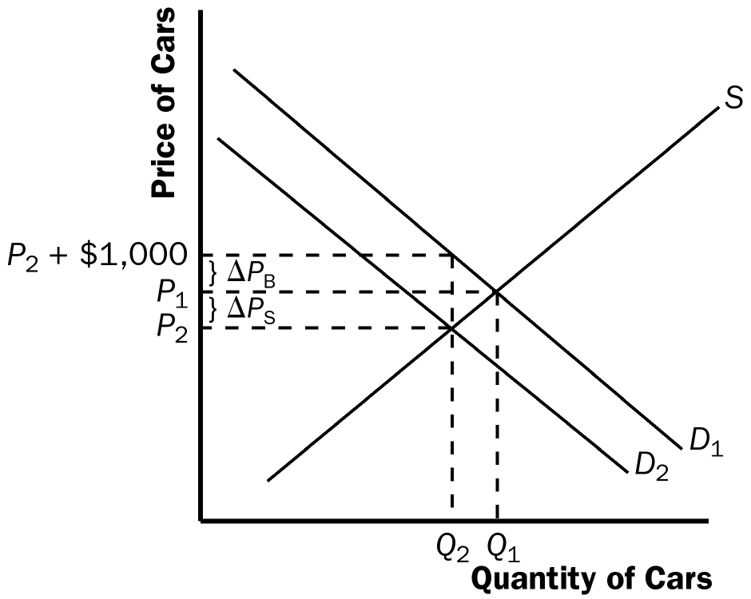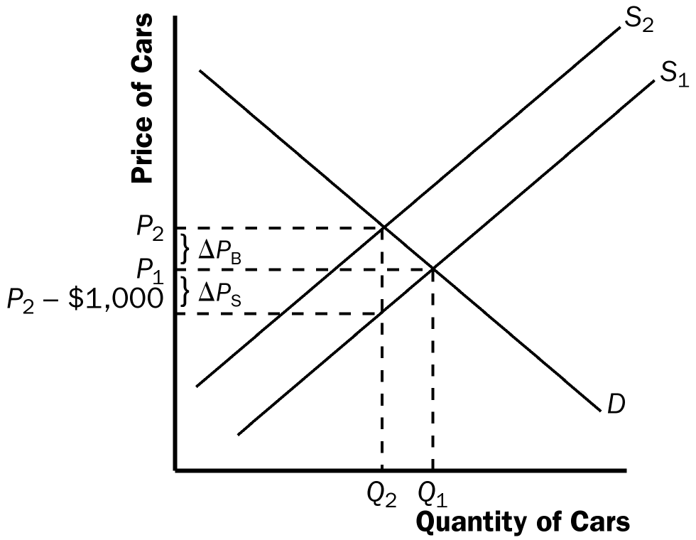

Figure 1 Figure 2

If the tax is imposed on car sellers, as shown in Figure 2, the supply curve shifts upward by the amount of the tax ($1,000) to S₂. The upward shift in the supply curve leads to a rise in the price paid by buyers to P₂ and a decline in the equilibrium quantity to Q₂. The price paid by buyers increases by P₂ – P₁, shown in the figure as ΔP_{B}. Sellers receive P₂ – 1,000, a decrease in what they receive by P₁ – (P₂ – $1,000), shown in the figure as ΔP_{S}.

Questions for Review

1. An example of a price ceiling is the rent control system in New York City. An example of a price floor is the minimum wage. Many other examples are possible.

2. A shortage of a good arises when there is a binding price ceiling. A binding price ceiling is one that is placed below the market equilibrium price. This leads to a shortage because quantity demanded exceeds quantity supplied. See Figure 3.

Figure 3

3. When the price of a good is not allowed to bring supply and demand into equilibrium, some alternative mechanism must allocate resources. If quantity supplied exceeds quantity demanded, so that there is a surplus of a good as in the case of a binding price floor, sellers may try to appeal to the personal biases of the buyers. If quantity demanded exceeds quantity supplied, so that there is a shortage of a good as in the case of a binding price ceiling, sellers can ration the good according to their personal biases, or make buyers wait in line.

4. Economists usually oppose controls on prices because prices have the crucial job of coordinating economic activity by balancing demand and supply. When policymakers set controls on prices, they obscure the signals that guide the allocation of society’s resources. Furthermore, price controls often hurt those they are trying to help.

5. Removing a tax paid by buyers and replacing it with a tax paid by sellers raises the price that buyers pay sellers by the amount of the tax, has no effect on the amount buyers are out of pocket, has no effect on the amount sellers receive net of any tax payments they make, increases the price received by sellers, and has no effect on the quantity of the good sold.

6. A tax on a good raises the price buyers pay, lowers the price sellers receive, and reduces the quantity sold.

7. The burden of a tax is divided between buyers and sellers depending on the elasticities of demand and supply. Elasticity represents the willingness of buyers or sellers to leave the market, which in turns depends on their alternatives. When a good is taxed, the side of the market with fewer good alternatives cannot easily leave the market and thus bears more of the burden of the tax.

Quick Check Multiple Choice

1. d

2. c

3. a

4. a

5. d

6. d

Problems and Applications

1. If the price ceiling of $40 per ticket is below the equilibrium price, then quantity demanded exceeds quantity supplied, so there will be a shortage of tickets. The policy decreases the number of people who attend classical music concerts, because the quantity supplied is lower because of the lower price.

2. a. The imposition of a binding price floor in the cheese market is shown in Figure 4. In the absence of the price floor, the price would be P₁ and the quantity would be Q₁. With the floor set at P_{f}, which is greater than P₁, the quantity demanded is Q₂, while quantity supplied is Q₃, so there is a surplus of cheese in the amount Q₃ – Q₂.
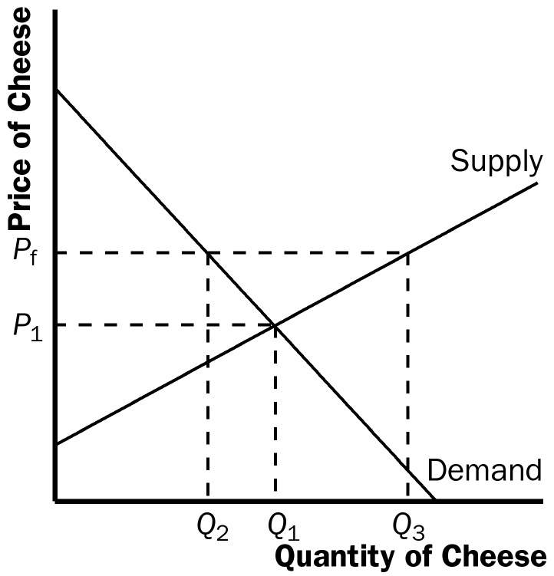

Figure 4

b. The producers’ complaint that their total revenue has declined is correct if demand is elastic. With elastic demand, the percentage decline in quantity would exceed the percentage rise in price, so total revenue would decline.

c. If the government purchases all the surplus cheese at the price floor, producers benefit and taxpayers lose. Producers would produce quantity Q₃ of cheese, and their total revenue would increase substantially. However, consumers would buy only quantity Q₂ of cheese, so they are in the same position as before. Taxpayers lose because they would be financing the purchase of the surplus cheese through higher taxes.

3. a. The equilibrium price of Frisbees is $8 and the equilibrium quantity is six million Frisbees.

b. With a price floor of $10, the new market price is $10 because the price floor is binding. At that price, only two million Frisbees are sold, because that is the quantity demanded.

c. If there’s a price ceiling of $9, it has no effect, because the market equilibrium price is $8, which is below the ceiling. So the market price is $8 and the quantity sold is six million Frisbees.

4. a. Figure 5 shows the market for beer without the tax. The equilibrium price is P₁ and the equilibrium quantity is Q₁. The price paid by consumers is the same as the price received by producers, P₁.

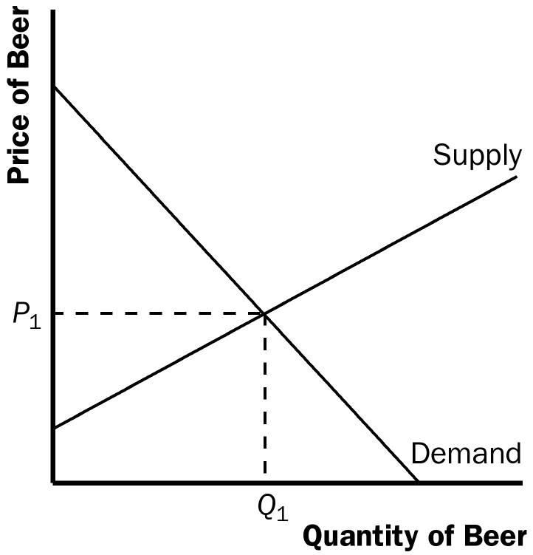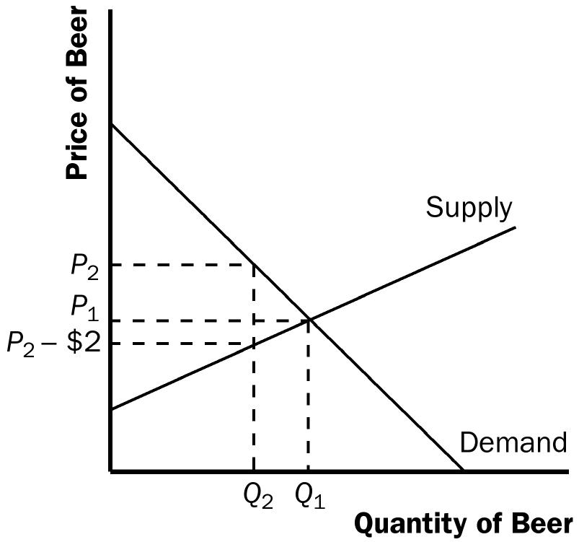

Figure 5 Figure 6

b. When the tax is imposed, it drives a wedge of $2 between supply and demand, as shown in Figure 6. The price paid by consumers is P₂, while the price received by producers is
P₂ – $2. The difference between the price paid by consumers and the price received by producers is the $2 tax. The quantity of beer sold declines to Q₂.

5. Raising the payroll tax paid by firms and using part of the extra revenue to reduce the payroll tax paid by workers would not make workers better off, because the division of the burden of a tax depends on the elasticity of supply and demand and not on who must pay the tax. Because the tax wedge would be larger, it is likely that both firms and workers, who share the burden of any tax, would be worse off.

6. The price will rise by less than $500. The burden of any tax is shared by both producers and consumers⎯the price paid by consumers rises and the price received by producers falls, with the difference between the two equal to the amount of the tax. The only exceptions would be if the supply curve were perfectly elastic or the demand curve were perfectly inelastic, in which case consumers would bear the full burden of the tax and the price paid by consumers would rise by exactly $500.

7. a. It does not matter whether the tax is imposed on producers or consumers⎯the effect will be the same. With no tax, as shown in Figure 7, the demand curve is D₁ and the supply curve is S₁. If the tax is imposed on producers, the supply curve shifts left by the amount of the tax (50 cents) to S₂. Then the equilibrium quantity is Q₂, the price paid by consumers is P₂, and the price received (after taxes are paid) by producers is P₂ – 50 cents. If the tax is instead imposed on consumers, the demand curve shifts left by the amount of the tax (50 cents) to D₂. The leftward shift in the demand curve (when the tax is imposed on consumers) is exactly the same magnitude as the leftward shift in the supply curve when the tax is imposed on producers. So again, the equilibrium quantity is Q₂, the price paid by consumers is P₂ (including the tax paid to the government), and the price received by producers is P₂ – 50 cents.

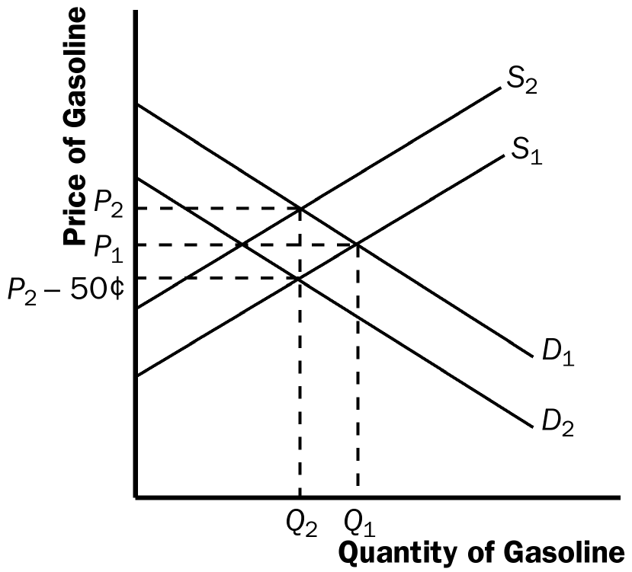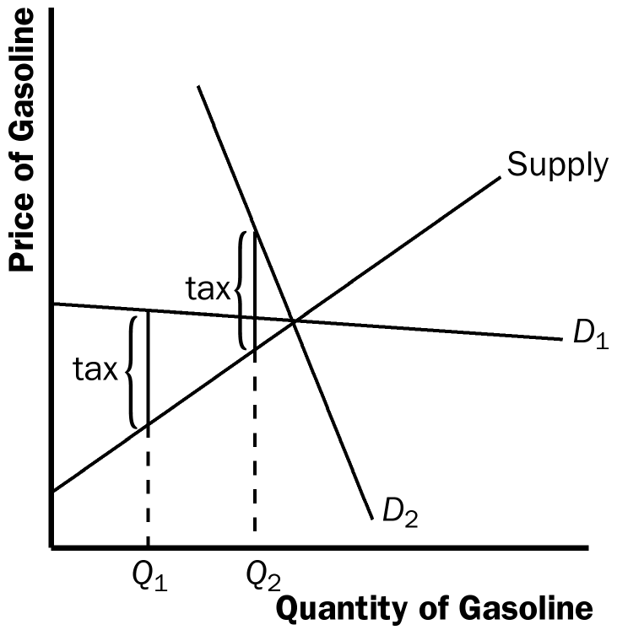

Figure 7 Figure 8

b. The more elastic the demand curve is, the more effective this tax will be in reducing the quantity of gasoline consumed. Greater elasticity of demand means that quantity falls more in response to the rise in the price. Figure 8 illustrates this result. Demand curve D₁ represents an elastic demand curve, while demand curve D₂ is more inelastic. The tax will cause a greater decline in the quantity sold when demand is elastic.

c. The consumers of gasoline are hurt by the tax because they get less gasoline at a higher price.

d. Workers in the oil industry are hurt by the tax as well. With a lower quantity of gasoline being produced, some workers may lose their jobs. With a lower price received by producers, wages of workers might decline.

8. a. Figure 9 shows the effects of the minimum wage. In the absence of the minimum wage, the market wage would be w₁ and Q₁ workers would be employed. With the minimum wage (w_{m}) imposed above w₁, the market wage is w_{m}, the number of employed workers is Q₂, and the number of workers who are unemployed is Q₃ − Q₂. Total wage payments to workers are shown as the area of rectangle ABCD, which equals w_{m} times Q₂.

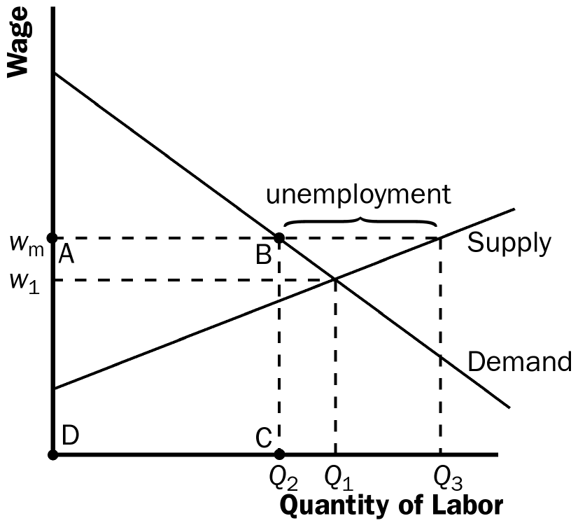

Figure 9

b. An increase in the minimum wage would decrease employment. The size of the effect on employment depends only on the elasticity of demand. The elasticity of supply does not matter, because there is a surplus of labor.

c. The increase in the minimum wage would increase unemployment. The size of the rise in unemployment depends on both the elasticities of supply and demand. The elasticity of demand determines the change in the quantity of labor demanded, the elasticity of supply determines the change in the quantity of labor supplied, and the difference between the quantities supplied and demanded of labor is the amount of unemployment.

d. If the demand for unskilled labor were inelastic, the rise in the minimum wage would increase total wage payments to unskilled labor. With inelastic demand, the percentage decline in employment would be lower than the percentage increase in the wage, so total wage payments increase. However, if the demand for unskilled labor were elastic, total wage payments would decline, because then the percentage decline in employment would exceed the percentage increase in the wage.

9. Since the supply of seats is perfectly inelastic, the entire burden of the tax will fall on the team’s owners. Figure 11 shows that the price the buyers pay for the tickets will fall by the exact amount of the tax.

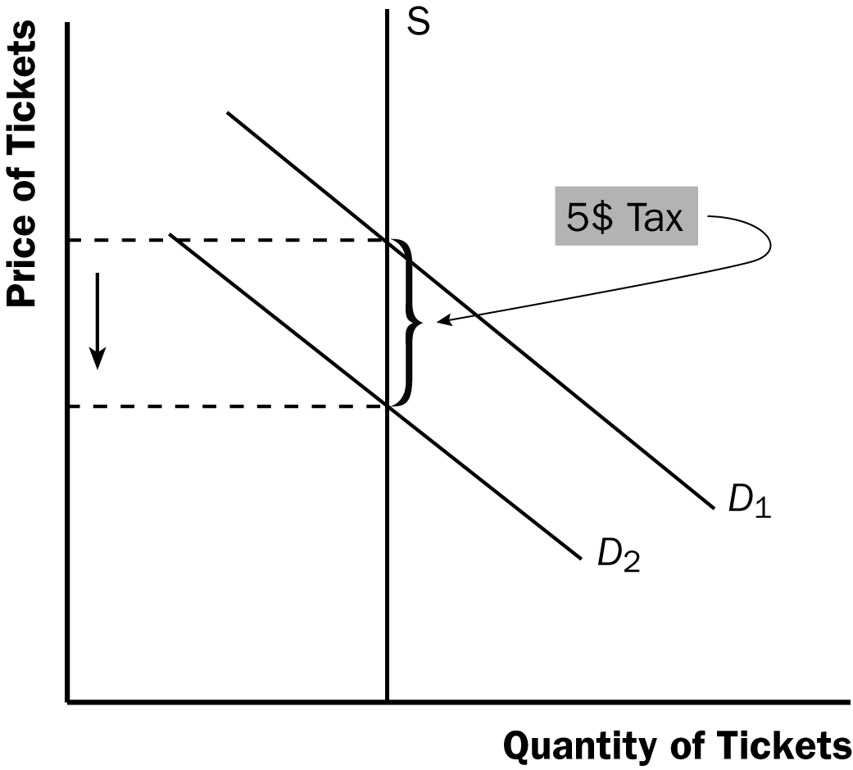

Figure 11
10. a. The effect of a $0.50 per cone subsidy is to shift the demand curve to the right by $0.50 at each quantity, because at each quantity a consumer's willingness to pay is $0.50 higher. The effects of such a subsidy are shown in Figure 12. Before the subsidy, the price is P₁. After the subsidy, the price received by sellers is P_{S} and the effective price paid by consumers is P_{D}, which equals P_{S} minus $0.50. Before the subsidy, the quantity of cones sold is Q₁; after the subsidy the quantity increases to Q₂.

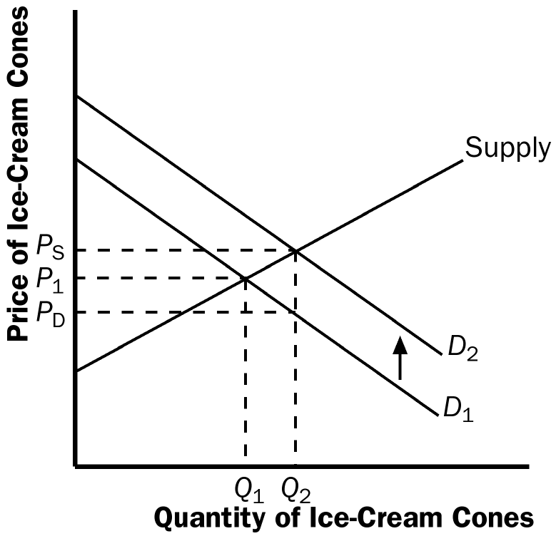

Figure 12

b. Consumers are better off with the subsidy, because they consume more at a lower price. Producers are also better off, because they sell more at a higher price. The government loses, because it has to pay for the subsidy.

